**Lab Assignment 8**

**AP21110010302**

**Krish Srivastava**

**CSE – E  
Network Security – CSE 315L**

**nat-t-ipsec-vpn.pcapng**

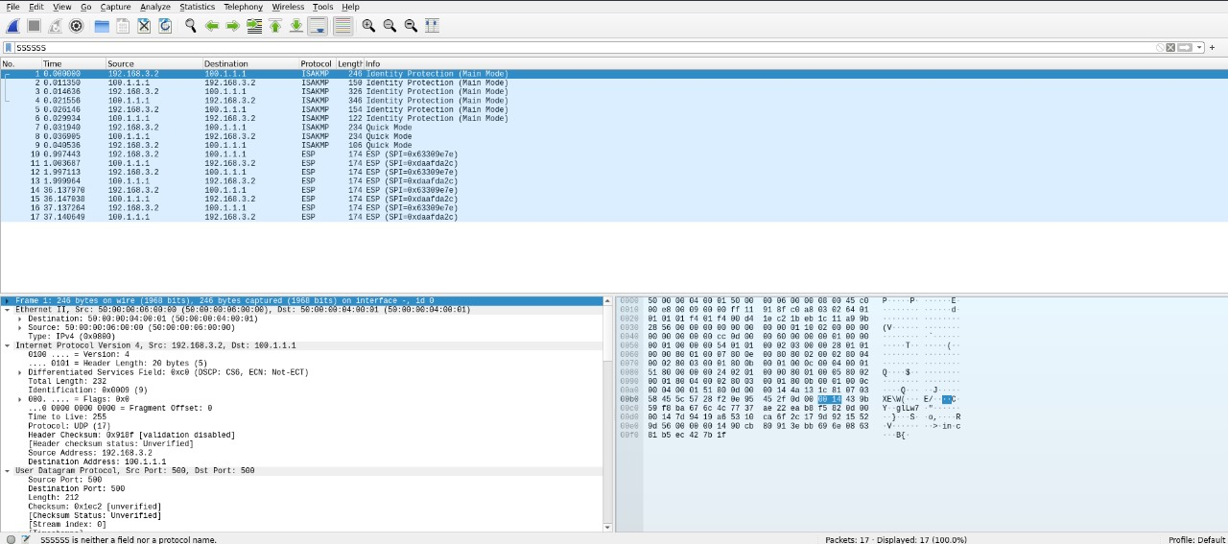

**ikev2_cbc_hmac.pcapng**

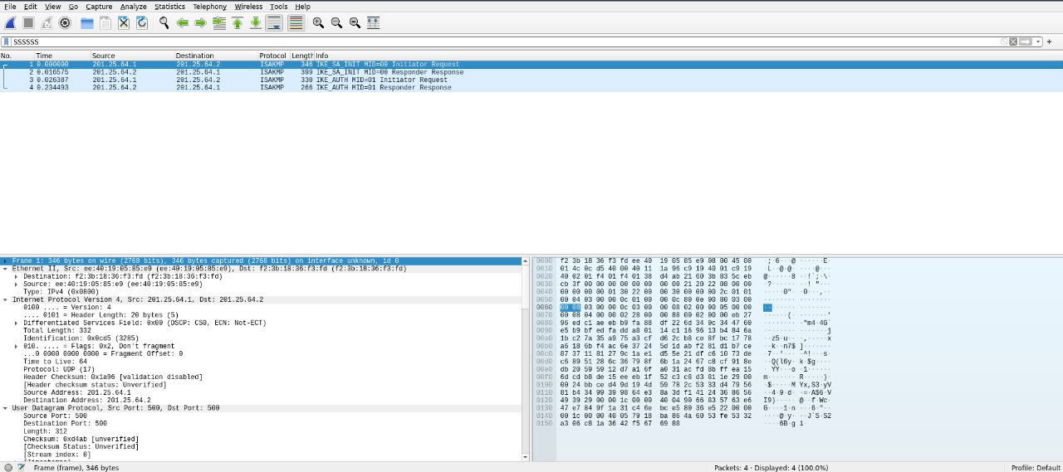

**esp4-ctr-hmac.pcapng**

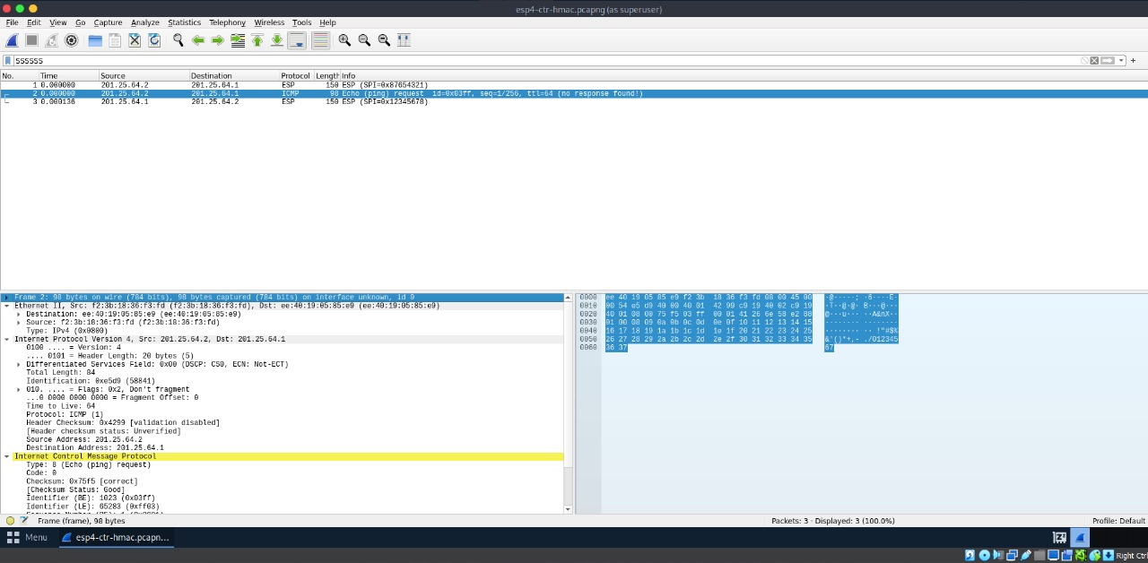

**esp-transport-esn.pcapng**

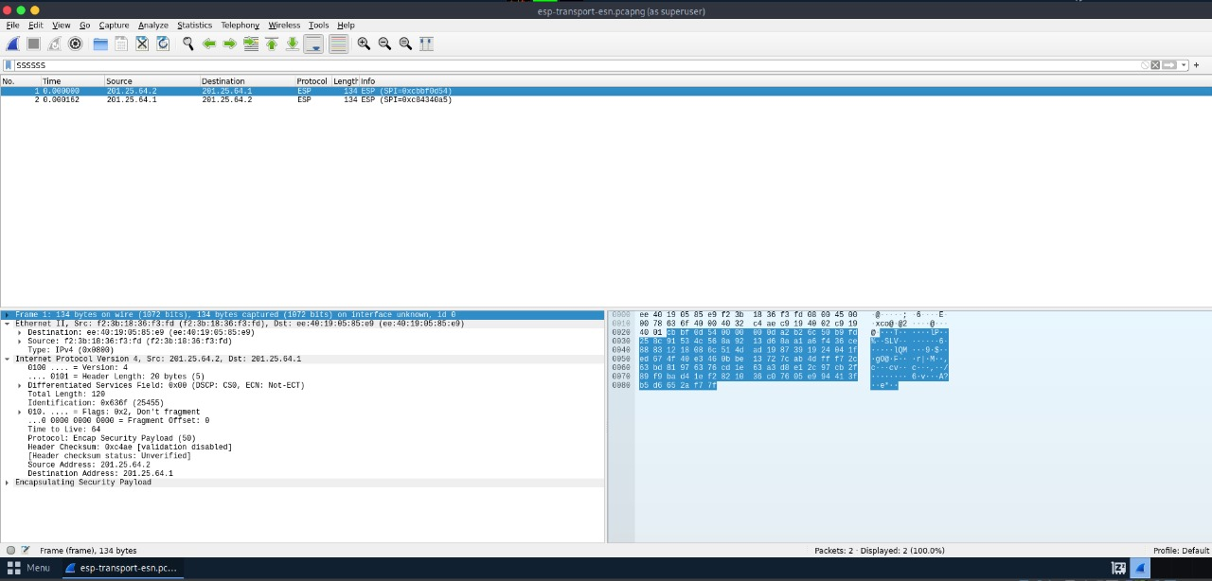

**ikev2.pcapng**

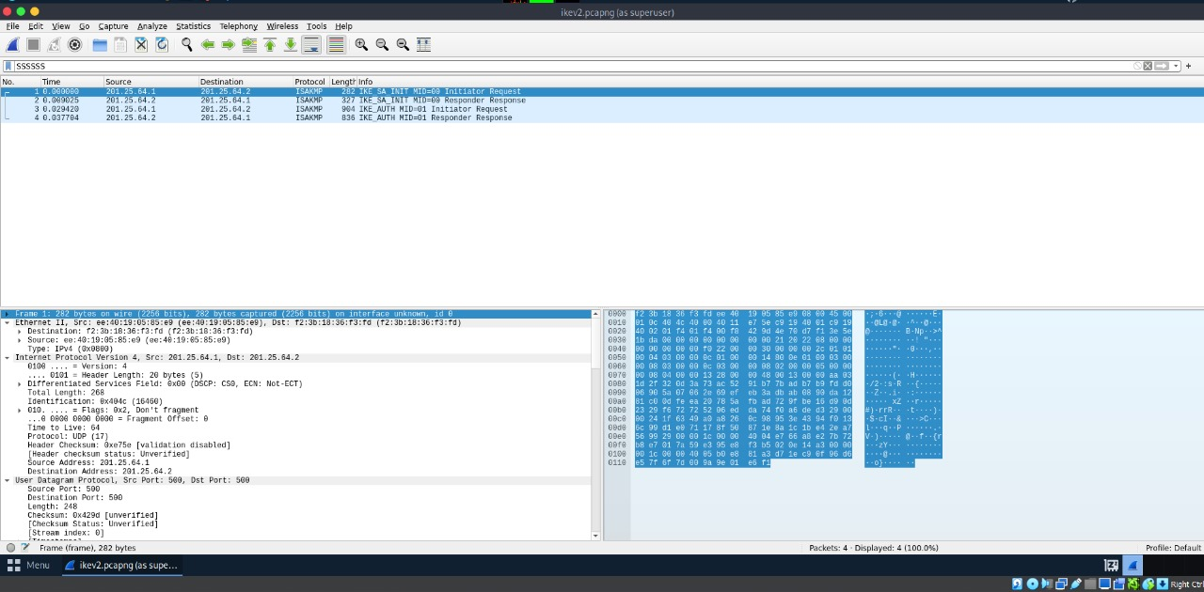

**ipv6_tcp.pcapng**

